
Linux System Administration (E1ITA307)
Linux Infrastructure Deployment Project Report
On
LINUX SERVER HEALTH MONITORING & ALERT SYSTEM
Submitted by
SHIVAM YADAV (2411021061438)
ARYA NILESHKUMAR MANOJ (2411021061473)
SHRIKRUSHNA PRAMOD BHISE (2411021061163)
In partial fulfillment of the award of the degree of
BACHELOR OF TECHNOLOGY
In
Information Technology
Under the Supervision of
Prof. Kusuma J

ALLIANCE SCHOOL OF ADVANCED COMPUTING
ALLIANCE UNIVERSITY
BENGALURU
October-2026
DEPARTMENT OF INFORMATION TECHNOLOGY
ALLIANCE SCHOOL OF ADVANCED COMPUTING

CERTIFICATE

This is to certify that the Project work entitled “Linux Server Health Monitoring & Alert System” submitted by Shivam Yadav [2411021061438], Arya Nileshkumar Manoj [2411021061473] and Shrikrushna Pramod Bhise [2411021061163] in partial fulfillment of the requirements for the award of the degree of Bachelor of Technology in Information Technology- IT - DA of Alliance University, is a bonafide work during the academic year 2026-2027.

Prof. Kusuma J | Prof. Kusuma J | Dr. Shekhar R
Course Handling Faculty | Course Coordinator | Professor & HoD
Table of Contents
1. Introduction 4
1.1 Aim 4
1.2 Background 4
1.3 Problem Statement 4
1.4 Objectives 5
2. Methodology 6
2.1 Tools and Technologies Used 6
2.2 Approach / Development Process 6
3. Linux System Administration – Design and Implementation 9
3.1 System Architecture 9
3.2 Linux Environment Setup 10
3.3 Terminal Tool (server_monitor.sh) 11
3.4 Web Dashboard (app.py – Flask) 14
3.5 Backup and Automation (Cron) 16
3.6 Security and Access Control 18
4. Results and Testing 20
4.1 Implementation Results 20
4.2 Testing and Validation 24
5. Conclusion and Future Scope 26
References 27
Appendix A – System Components Summary 27
Appendix B – Shell Script Source Code 28
Appendix C – Flask Dashboard Source Code 30

1. Introduction

1.1 Aim
The main aim of this mini project is to design, develop, and implement a Linux Server Health Monitoring and Alert System that monitors CPU usage, memory (RAM) utilisation, disk space, system uptime, logged-in users, running processes, and optional systemd service status on an Ubuntu Linux machine.
The system is implemented in two complementary forms: a menu-driven Bash terminal tool (server_monitor.sh) and a web-based Flask dashboard (app.py). Both interfaces collect live data from the Linux kernel and standard utilities, compare the readings against user-configurable thresholds, and display clear OK or WARNING alerts. Timestamped reports and activity logs are saved automatically for later review.

1.2 Background
Linux is the foundation of most servers, cloud infrastructure, enterprise systems, and academic computing environments. Monitoring the health of a Linux machine — CPU load, available memory, disk capacity, active users, and running services — is a routine but essential administrative duty.
Professional monitoring tools such as Nagios, Zabbix, Prometheus, or Grafana are powerful but complex. They require installation of databases, web servers, and many dependencies. For a student learning Linux system administration, or for a junior administrator who only needs a quick health check, such tools are overkill.
This project builds a self-contained monitoring solution from scratch using only Bash shell scripting and Python (Flask). No external monitoring agent, database, or cloud service is required. Everything runs locally on an Ubuntu machine, reads real kernel data, and writes plain text files.

1.3 Problem Statement
Checking the health of a Linux server normally requires remembering and running several separate commands — df for disk, free for memory, top or ps for CPU and processes, who for logged-in users, and systemctl for service status. Beginners and time-pressed administrators may miss problems until they become serious. There is also no automatic record of what was observed unless the administrator manually saves the output.
Therefore, this project develops an integrated Linux Server Health Monitoring and Alert System that provides a single guided interface (menu or browser), collects all key health metrics in one operation, compares them with defined thresholds, shows clear pass/fail alerts, and saves timestamped reports and logs automatically.

1.4 Objectives
The main objectives of the Linux Server Health Monitoring and Alert System are:
- To monitor CPU usage, RAM utilisation, disk space, system uptime, logged-in users, and running processes using standard Linux commands and /proc filesystem readings.
- To provide a menu-driven terminal interface (server_monitor.sh) with eleven numbered options for interactive use on any Ubuntu terminal.
- To provide a web dashboard (Flask app.py) with seven tabs that displays live gauges, sparkline charts, and a process table in a browser, refreshing every three seconds, and lets the user check a service, change thresholds, generate and download reports, and view the activity log.
- To compare CPU, RAM, and disk usage against configurable warning thresholds and display OK or WARNING alerts with colour coding.
- To generate timestamped plain-text health reports and maintain a structured activity log (logs/app.log) for audit purposes.
- To validate all user input (menu choices, threshold values, service names) and recover gracefully from missing utilities, unavailable systemd, or permission errors.
- To run on Ubuntu Linux without requiring sudo, a database, or any external network service.
- To demonstrate core Linux administration concepts: process management, filesystem inspection, user activity monitoring, service status checking, and file permissions.

2. Methodology

2.1 Tools and Technologies Used

2.1.1 Software Requirements
The Linux Server Health Monitoring and Alert System was developed using Ubuntu Linux, Bash shell scripting, Python (Flask), and standard Linux utilities. The system has two delivery modes: an interactive terminal menu and a live browser dashboard.
Tool / Technology | Purpose
Ubuntu Linux 24.04 LTS | Operating system for development and target deployment
Bash (v5+) | Shell scripting language for server_monitor.sh terminal tool
Python 3 + Flask | Backend web framework for the browser dashboard (app.py)
HTML / CSS / JavaScript | Frontend of the web dashboard rendered in the browser
/proc filesystem | Kernel data source for CPU (/proc/stat) and RAM (/proc/meminfo)
df -P -k | Disk space information (POSIX format, 1-KB blocks)
ps, who, uptime | Process list, logged-in users, and uptime information
systemctl | Service status check (optional, requires systemd)
Cron | Schedules automatic health checks and report generation
tar + gzip | Creates and inspects the compressed project backup archive
APT + tree | Package management and project directory structure display

2.1.2 Hardware Requirements
The project was implemented on a computer running Ubuntu Linux (physical machine or VirtualBox VM). General hardware requirements include:
- A laptop or desktop computer capable of running Ubuntu Linux 22.04 or 24.04.
- A compatible x86-64 processor.
- At least 2 GB RAM (4 GB recommended for VirtualBox).
- At least 20 GB of available disk space for the operating system and project files.
- Network access is not required; all monitoring is local.

2.2 Approach / Development Process
The project was developed in structured stages, covering problem identification, environment setup, implementation, web dashboard development, cron automation, testing, and documentation.

Step 1: Problem Identification
The need for an integrated health monitoring tool was identified. The system was designed to monitor CPU, RAM, disk, uptime, users, processes, and service status from a single interface, compare readings with configurable thresholds, and produce timestamped reports.

Step 2: Linux Environment Setup
An Ubuntu Linux environment was configured. A project directory (linux-server-monitor) was created to organise Bash scripts, a Python Flask backend, configuration files, logs, reports, and backups.

Step 3: Terminal Tool Implementation (server_monitor.sh)
The core Bash script was developed with eleven menu options covering all monitoring features. Thresholds are stored in data/config.conf and compared using integer arithmetic (tenths of a percent) to avoid floating-point tools.

Step 4: Web Dashboard Implementation (app.py)
A single-file Python Flask application was developed. The backend exposes a JSON API: /api/metrics reads real-time system data using the same sources as the Bash script, and further endpoints handle the service check, threshold configuration, report generation and download, and the activity log. The frontend, embedded in the same file as an HTML string, is organised into seven tabs (Dashboard, Processes, Network, Service Check, Thresholds, Reports and Logs) that render live gauges, sparkline charts, tables and forms. A background thread samples CPU, network and per-process CPU once per second, so every request is answered in a few milliseconds. The dashboard uses the same data/ folder as the terminal tool, so both share one configuration file, one log and one report folder.

Step 5: Cron Automation
Cron was configured to run the Bash script on a schedule using its non-interactive options: --check every 5 minutes for the threshold check and --report every 15 minutes to generate periodic health reports.

Step 6: Security and Access Control
File permissions were set correctly: scripts are executable (chmod +x), output files are owner-read-write only (umask 077). Service names entered by the user are validated with a strict regular expression before being passed to systemctl.

Step 7: Testing and Documentation
The system was tested by verifying monitoring outputs against direct Linux commands (df -h /, free -m, top), testing threshold edge cases, testing invalid input rejection, and checking report and log file creation. All test results are recorded in TEST_CHECKLIST.md. Documentation was prepared in the form of a README, this report, a presentation, and inline code comments.

3. Linux System Administration – Design and Implementation

3.1 System Architecture
The Linux Server Health Monitoring and Alert System is a local, single-machine Bash and Python CLI application. It has two runtime modes: an interactive Bash terminal menu and a Python Flask web server that serves a browser dashboard.
The system runs entirely on Ubuntu Linux. Monitoring scripts collect system information from /proc filesystem entries and standard Linux utilities, compare usage against configured thresholds, record measurements, generate alerts when required, and store plain-text reports and logs. A cron scheduler automates periodic monitoring and report generation.
Figure 3.1 presents the system architecture and component relationships.
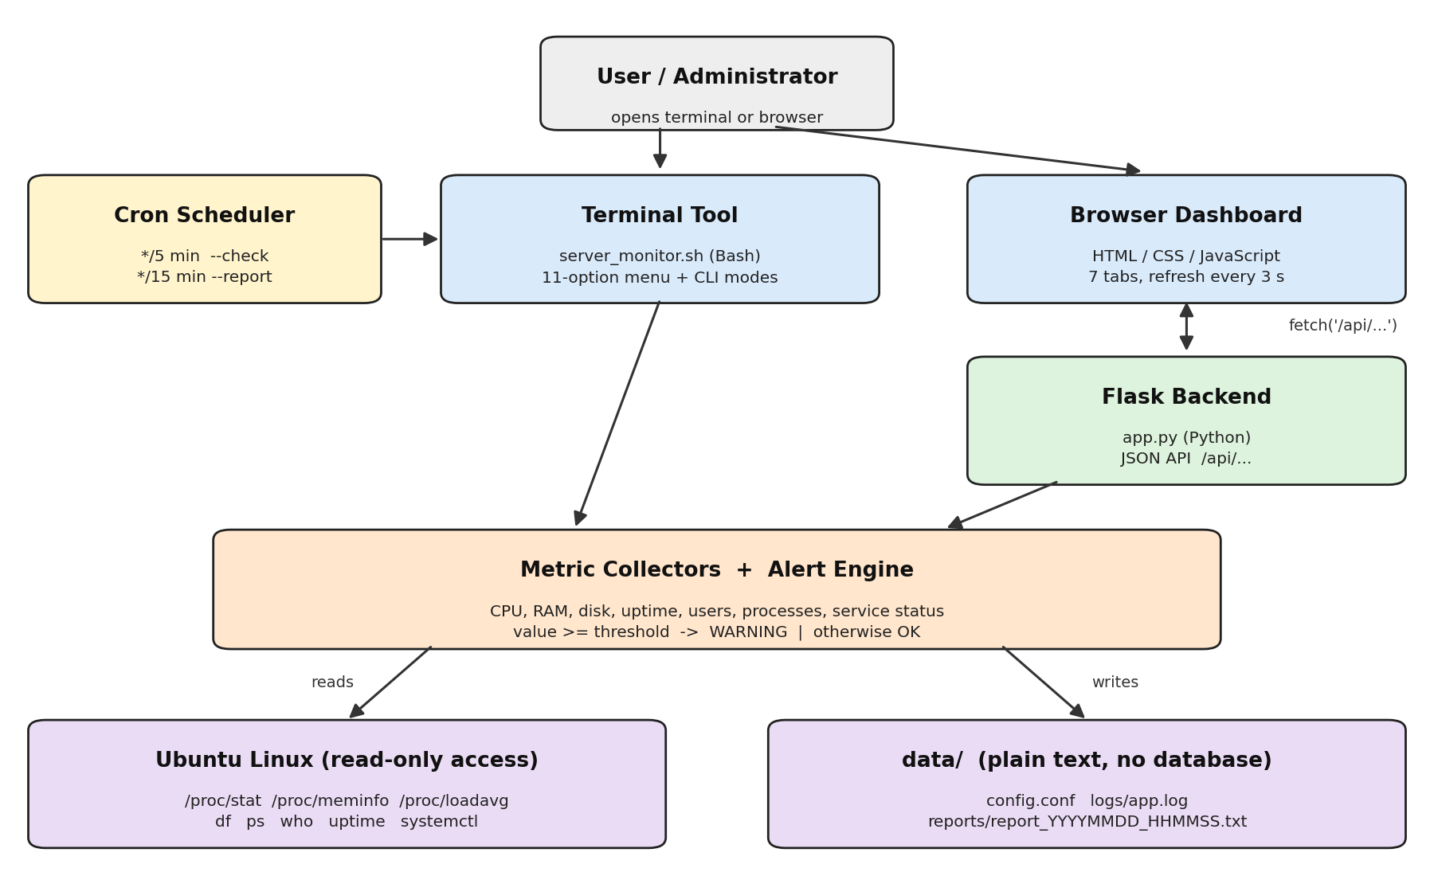
Figure 3.1: System Architecture of Linux Server Health Monitoring & Alert System

3.1.1 Components and Their Roles
Component | Role
User / Administrator | Runs the Bash menu or opens the browser dashboard; reviews reports and logs.
Ubuntu Linux Server | Provides the /proc filesystem, Linux utilities (df, ps, who, uptime), and systemd.
server_monitor.sh (Bash) | Menu-driven terminal tool with 11 options. Reads /proc/stat, /proc/meminfo, df, ps, who, systemctl. Also runs non-interactively (--check, --report) for cron.
app.py (Flask) | Python web server. Exposes /api/metrics plus service, threshold, report and log endpoints; a background thread samples CPU once per second. Serves the browser dashboard.
Browser Dashboard (HTML/JS) | Seven tabs: live gauges, sparklines, tables, service check, threshold form, reports and logs. Auto-refreshes every 3 seconds via fetch('/api/metrics').
data/config.conf | Stores CPU, RAM, and disk thresholds as plain KEY=VALUE lines (parsed, not sourced). Shared by the terminal tool and the web dashboard.
logs/app.log | Timestamped activity and error log: [INFO], [WARN], [ERROR] entries.
data/reports/ | Timestamped plain-text health reports (report_YYYYMMDD_HHMMSS.txt).
Cron Scheduler | Runs server_monitor.sh --check every 5 minutes and server_monitor.sh --report every 15 minutes.
Backup Archive | backup/project_backup.tar.gz – compressed copy of scripts and configuration.

3.2 Linux Environment Setup

3.2.1 Linux Distribution and Version
The project was developed and tested on Ubuntu Linux. The system information was verified using lsb_release -a and hostnamectl. The root filesystem is formatted with ext4 and mounted at /. The monitoring system reads from /proc/stat, /proc/meminfo, /proc/loadavg, /proc/uptime, /proc/net/dev, and /proc/cpuinfo.
Figure 3.2 records the Ubuntu version and filesystem details.
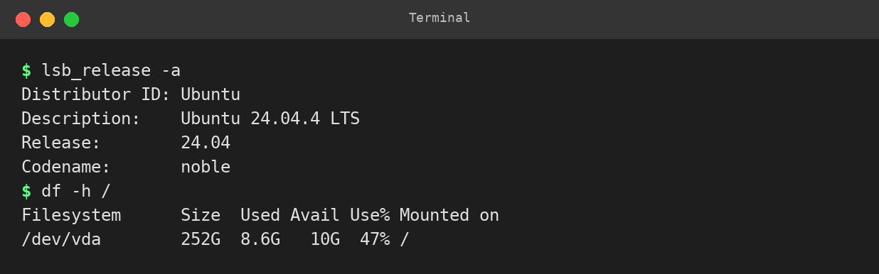
Figure 3.2: Ubuntu version (lsb_release -a) and root filesystem details (df -h /)

3.2.2 Project Directory Structure
The project directory linux-server-monitor was created in the user's home directory. The Bash script (server_monitor.sh), README.md and TEST_CHECKLIST.md sit in the project root; separate folders hold the Flask backend (web/), documentation (docs/), run-time data (data/ – configuration, logs and reports) and backups (backup/). The tree utility displays the structure.
The commands used to set up and verify the project structure are:
cd ~/linux-server-monitor
pwd
tree
find . -maxdepth 2 -type f

3.2.3 Required Packages
The project uses Bash and standard Linux utilities pre-installed on Ubuntu: df, ps, who, uptime, date, sleep, head, tail, sed, and uname. Python 3 and Flask are required for the web dashboard. The tree utility is optional (for directory display). The tar and gzip utilities create and inspect the compressed backup archive.
bash --version
python3 --version
pip3 install flask
tree --version
tar --version
gzip --version

3.3 Terminal Tool (server_monitor.sh)

3.3.1 Menu Interface
The terminal tool presents a numbered menu with eleven options. The user types a number and presses Enter. The chosen feature runs, results are displayed, and the user presses Enter to return to the menu. Invalid input (letters, out-of-range numbers, empty input) is rejected with a clear error message and the menu is redisplayed.
╔══════════════════════════════════════════════════════╗
║ LINUX SERVER HEALTH MONITORING & ALERT SYSTEM ║
╚══════════════════════════════════════════════════════╝
Thresholds: CPU 80% RAM 80% Disk 80%

1) Show system health summary
2) Show CPU details
3) Show memory details
4) Show disk usage
5) Show uptime, logged-in users and top processes
6) Check a system service
7) Configure alert thresholds
8) Check all thresholds / show alerts
9) Generate a report
10) View recent logs/reports
11) Exit
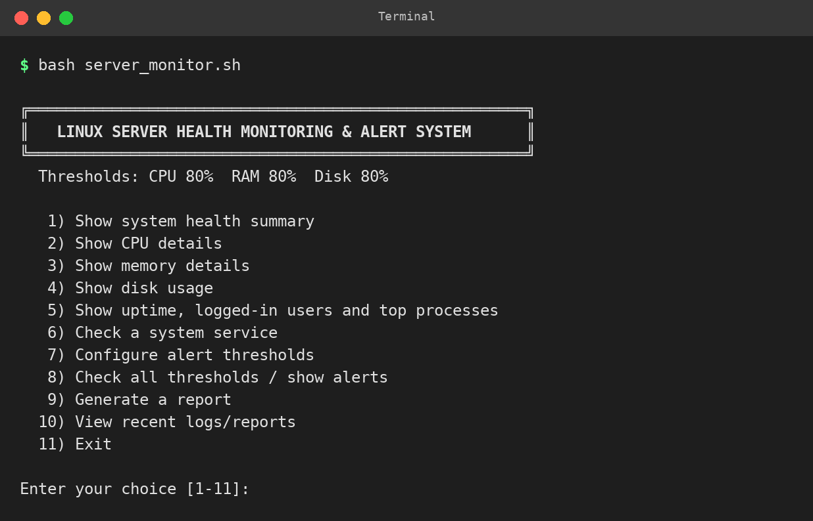
Figure 3.3: Terminal tool main menu displayed on Ubuntu

3.3.2 CPU Measurement
CPU utilisation is measured by reading the aggregate cpu line from /proc/stat twice, one second apart, and computing the percentage of non-idle time over that interval. This gives a live one-second snapshot of CPU usage.
# Formula used in collect_cpu():
delta_total = total2 - total1
delta_idle = idle2 - idle1
cpu_percent = (delta_total - delta_idle) / delta_total * 100

# total = user + nice + system + idle + iowait + irq + softirq + steal
# idle = idle + iowait
If /proc/stat cannot be read or no time elapsed between samples, the CPU value is reported as UNAVAILABLE with the reason; no invented number is displayed.

3.3.3 Memory Measurement
Memory information is read from /proc/meminfo. Used memory is computed as MemTotal minus MemAvailable (the kernel's estimate of memory that can be reclaimed without swapping). This matches the 'used' column of the free command. Values are displayed in MiB or GiB.

3.3.4 Disk Measurement
Disk usage for the root filesystem (/) is obtained from df -P -k /. The Use% figure reported by df is used directly, so it can be verified by typing df -h / in another terminal. All mounted filesystems (excluding tmpfs and devtmpfs) are listed for information.

3.3.5 Alert Engine
The alert rule is: WARNING when the measured percentage is greater than or equal to the configured threshold; OK otherwise. Percentages are stored internally as integer tenths (e.g., 45.3% is stored as 453) to allow exact comparison in pure Bash without floating-point tools.
metric_status() {
local value=$1 threshold=$2
if [ -z "$value" ]; then
printf 'UNAVAILABLE'
elif [ "$value" -ge $(( threshold * 10 )) ]; then
printf 'WARNING'
else
printf 'OK'
fi
}
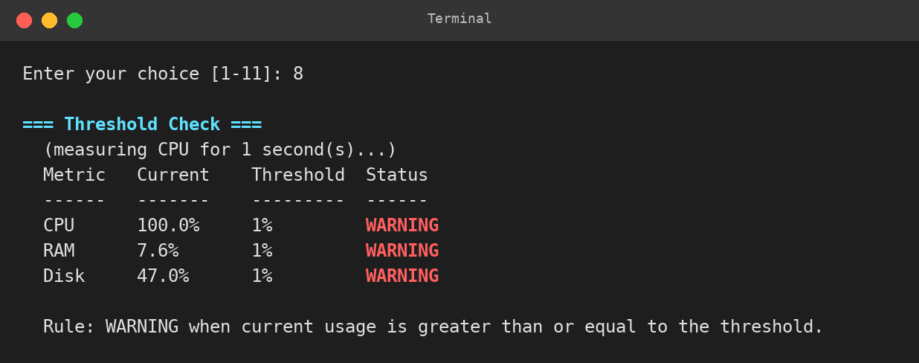
Figure 3.4: Alert table with all thresholds set to 1% (all WARNING)

3.3.6 Threshold Configuration
Thresholds are stored in data/config.conf as three plain KEY=NUMBER lines. The file is never sourced as shell code; it is parsed line by line, accepting only lines that exactly match CPU_THRESHOLD=, RAM_THRESHOLD=, or DISK_THRESHOLD= followed by a valid integer from 1 to 100. Any invalid line causes the file to be repaired with defaults (80/80/80). When a threshold is saved, a temporary file is written and then moved into place atomically.
# data/config.conf – structure
CPU_THRESHOLD=80
RAM_THRESHOLD=80
DISK_THRESHOLD=80

3.3.7 Service Check
The user types a service name which is validated by a strict regular expression: it must start with a letter or digit, may then contain letters, digits and the characters . _ - @ : and may be at most 128 characters long. The validated name is passed to systemctl as a single quoted argument after --, so it can never be interpreted as a shell command. If systemctl is missing or systemd is not running, the feature reports 'unavailable' and returns to the menu.

3.3.8 Reports and Logs
Menu option 9 generates a plain-text report named report_YYYYMMDD_HHMMSS.txt in data/reports/. The report contains: system information, CPU details, memory details, disk details, all filesystems, uptime and load, logged-in users, top 10 processes by CPU, and the alert table. If a report file with the same timestamp already exists, a counter suffix (_1, _2 …) is added so no earlier report is overwritten. The log file (logs/app.log) receives one line per event with a timestamp and severity level (INFO, WARN, or ERROR).

3.4 Web Dashboard (app.py – Flask)

3.4.1 Architecture
The web dashboard is a single Python file (app.py) that uses Flask to serve an embedded HTML page and a small JSON API. The backend reads real-time data using the same sources as the Bash script (/proc/stat, /proc/meminfo, df, ps, who). The frontend receives the JSON data and renders live visual components in the browser.
Figure 3.5 shows the web dashboard in the browser, which refreshes through the data-flow between the browser and the Flask backend.
Browser (HTML/CSS/JavaScript)
│ fetch('/api/metrics') every 3 seconds
▼
Python Flask backend (app.py)
│ reads /proc/stat, /proc/meminfo, df, ps, who
▼
Ubuntu Linux kernel + standard utilities

3.4.2 API Endpoint
The /api/metrics endpoint returns a JSON object containing all monitoring data in a single request. The frontend calls this endpoint every three seconds using the browser's setInterval mechanism.
JSON Key | Source | Contents
cpu | /proc/stat (2 samples) | percent, model, cores
mem | /proc/meminfo | percent, total_mb, used_mb, free_mb
disk | df -P -k / | percent, fs, mount, total_gb, used_gb, free_gb
disks | df -P -h (all) | All mounted real filesystems
load | /proc/loadavg | 1-min, 5-min, 15-min load averages
uptime | /proc/uptime | Human-readable uptime string
os | /etc/os-release, uname | OS name, kernel version, hostname
procs | ps --sort=-pcpu | Top 10 processes by CPU
users | who | Currently logged-in users
net | /proc/net/dev | RX/TX bytes per interface
thresholds | data/config.conf | Current CPU, RAM and disk thresholds
alerts | thresholds vs readings | OK or WARNING for cpu, ram and disk
warnings | alerts | Number of metrics currently in WARNING

3.4.3 Dashboard Sections
Section | What it shows
CPU card | Live CPU % with colour gauge bar and threshold marker, sparkline chart (fixed 0–100% scale), load average (1/5/15 min)
Memory card | Used/available/total RAM, usage %, sparkline chart
Disk card | Root filesystem usage %, size/used/free in GiB, gauge bar
Alerts | OK ✓ or WARNING ⚠ for CPU, RAM, and Disk against the configured thresholds (default 80%)
Top Processes table | Top 10 processes by CPU: PID, user, CPU%, MEM%, command
All Filesystems table | Every mounted non-virtual filesystem with a progress bar
Network interfaces | Total bytes received and sent since boot per interface
Logged-in Users | Users from the who command with terminal and source
System Info | Hostname, OS name, kernel version, uptime, CPU model and cores
Header status pill | Green “✓ ALL OK” or red “⚠ n WARNING” for the whole server, visible on every tab
Service Check tab | Validates a service name and shows its active state, sub-state and start-at-boot state (systemctl)
Thresholds tab | Form to change the CPU, RAM and disk thresholds (1–100); saved to data/config.conf
Reports tab | Generate a timestamped report and download saved reports
Logs tab | Last 30 entries of the activity log (logs/app.log)
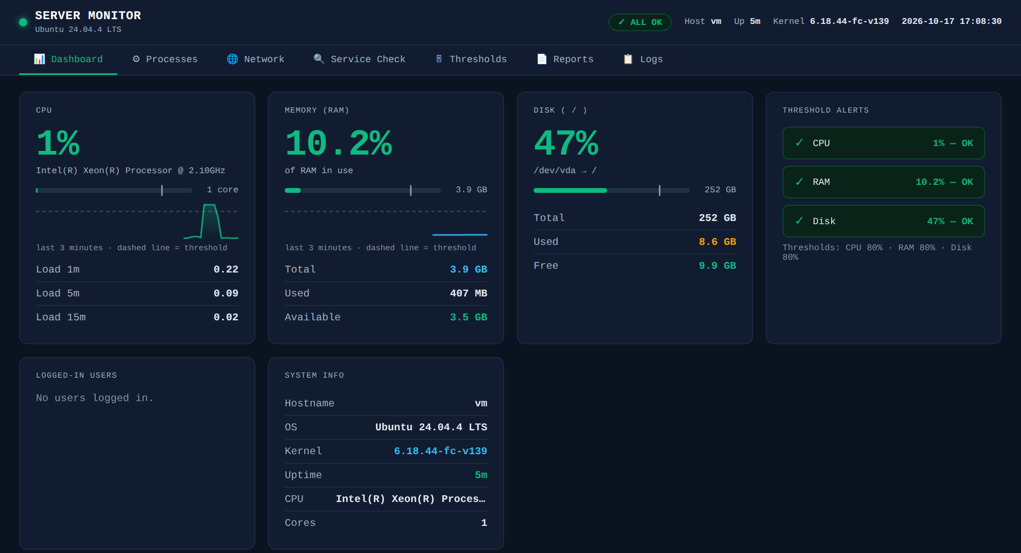
Figure 3.5: Web dashboard main view in the browser (http://localhost:5000)

3.4.4 Starting the Web Dashboard
The web dashboard requires Python 3 and Flask. It is started from the project directory with two commands:
# Install Flask once
pip3 install flask

# Start the dashboard
python3 web/app.py

# Open in browser
# http://localhost:5000
The server prints a startup message and runs on port 5000. The dashboard page auto-refreshes every 3 seconds; no manual interaction is needed. Thresholds, reports and the log are stored in the same data/ folder as the terminal tool. By default the server listens only on this machine (127.0.0.1); the option --host 0.0.0.0 opens it to the network, but the dashboard has no login, so this should be used only on a trusted network. To stop the server, press Ctrl+C in the terminal.

3.5 Backup and Automation (Cron)

3.5.1 Backup Strategy
A compressed archive (backup/project_backup.tar.gz) stores a copy of the project scripts, configuration file, and test files. The tar utility packages the selected files while gzip reduces the archive size. The archive can be listed and extracted without overwriting the live project files.
# Create backup
cd ~/linux-server-monitor
mkdir -p backup
tar -czf backup/project_backup.tar.gz server_monitor.sh web/ docs/ data/config.conf README.md TEST_CHECKLIST.md

# List contents
tar -tzf backup/project_backup.tar.gz

# Extract to a recovery directory
mkdir -p /tmp/recovery
tar -xzf backup/project_backup.tar.gz -C /tmp/recovery
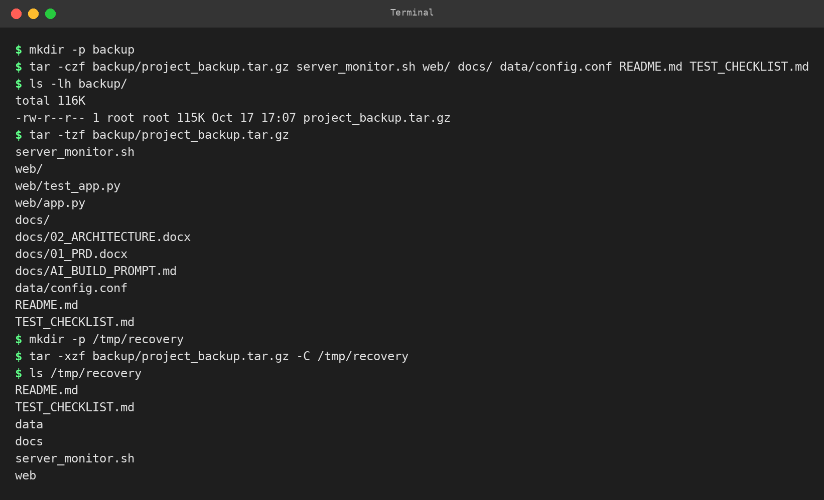
Figure 3.6: Backup archive created, listed, and verified

3.5.2 Cron Configuration
Cron is used to schedule the Bash monitoring tool and report generation automatically. The monitoring check runs every 5 minutes and report generation runs every 15 minutes. The Cron service status and configured jobs are verified with the following commands:
systemctl status cron --no-pager
systemctl is-active cron
crontab -l

# Crontab entries:
*/5 * * * * bash ~/linux-server-monitor/server_monitor.sh --check >/dev/null 2>&1
*/15 * * * * bash ~/linux-server-monitor/server_monitor.sh --report >/dev/null 2>&1
[ Insert Screenshot – Figure 3.7 ]
Cron service active and crontab entries listing
Figure 3.7: Cron service active and crontab entries listing
The two cron entries use the non-interactive options of server_monitor.sh. The option --check prints the alert table, writes any WARNING to logs/app.log and exits with status 0 (all OK) or 1 (at least one WARNING). The option --report saves one timestamped report and exits with status 0 on success. Figure 3.8 shows both options run from the terminal.
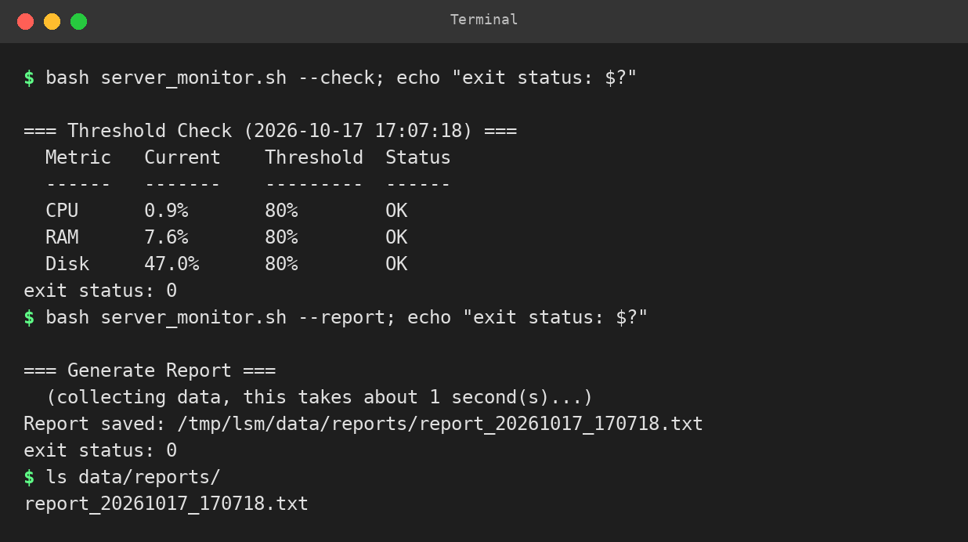
Figure 3.8: Non-interactive modes used by cron: --check (alert table and exit status) and --report (saved report)

3.6 Security and Access Control

3.6.1 Safety Design Principles
The Linux Server Health Monitoring and Alert System is designed as a read-only, non-destructive tool. The following security principles are applied throughout:
- No eval, no source: Configuration files are parsed line by line. No file is executed as shell code.
- No sudo: All monitoring reads data the current user can access. No privileged operations are performed.
- No kill, no restart: The tool only reports service status; it never starts, stops, or restarts services.
- Input validation: Menu choices, threshold values (integers 1–100), and service names (strict regex) are all validated before use.
- Quoted variables: All variables and paths are double-quoted throughout the script, preventing word-splitting and glob expansion.
- Safe file writes: Threshold changes are written to a temporary file and moved into place atomically; if saving fails, the previous value is restored. A new report never overwrites an earlier one (a counter suffix is added).
- Web dashboard safety: Listens on 127.0.0.1 by default; every POST needs a custom header, which blocks cross-site requests; every value shown in the page is HTML-escaped; report downloads accept only names such as report_YYYYMMDD_HHMMSS.txt; thresholds must be whole numbers from 1 to 100.
- File permissions: Data files are created with mode rw------- (umask 077). Only the current user can read logs and reports.
- Log sanitisation: User-typed text is cleaned (non-printable characters replaced) and truncated before being written to the log.

3.6.2 Service Name Validation
Service names entered by the user are validated with a strict regular expression before being passed to systemctl. The pattern accepts only names starting with a letter or digit, optionally followed by letters, digits and the characters . _ - @ : (maximum 128 characters total). This rejects option-like input (-x), shell metacharacters (; | & $ ` " '), spaces, and empty strings.
valid_service_name() {
local re='^[A-Za-z0-9][A-Za-z0-9@._:-]{0,127}$'
[[ $1 =~ $re ]]
}

4. Results and Testing

4.1 Implementation Results
The Linux Server Health Monitoring and Alert System was implemented successfully in two complementary forms. The Bash terminal tool provides eleven menu options covering all monitoring requirements. The Flask web dashboard delivers a live browser-based view of the same data with auto-refreshing gauges, sparklines, and tables. Both tools read real data from the Linux kernel and agree on the measured values when run simultaneously.

4.1.1 Terminal Tool Results
The following table summarises the key metrics observed on the development Ubuntu machine during implementation. Values will differ on the student's own VM.
Metric | Observed Value | Notes
CPU usage | 0–2% (idle) | 1-second sample from /proc/stat
RAM total | ~4 GB | From /proc/meminfo MemTotal
RAM used | ~200–400 MB | MemTotal − MemAvailable
Disk usage (/) | 47% | Matches df -h / Use%
Load average | 0.0–0.2 (1 min) | From /proc/loadavg
Report generated | Yes | data/reports/report_YYYYMMDD_HHMMSS.txt
Log entries | Yes | logs/app.log with timestamps
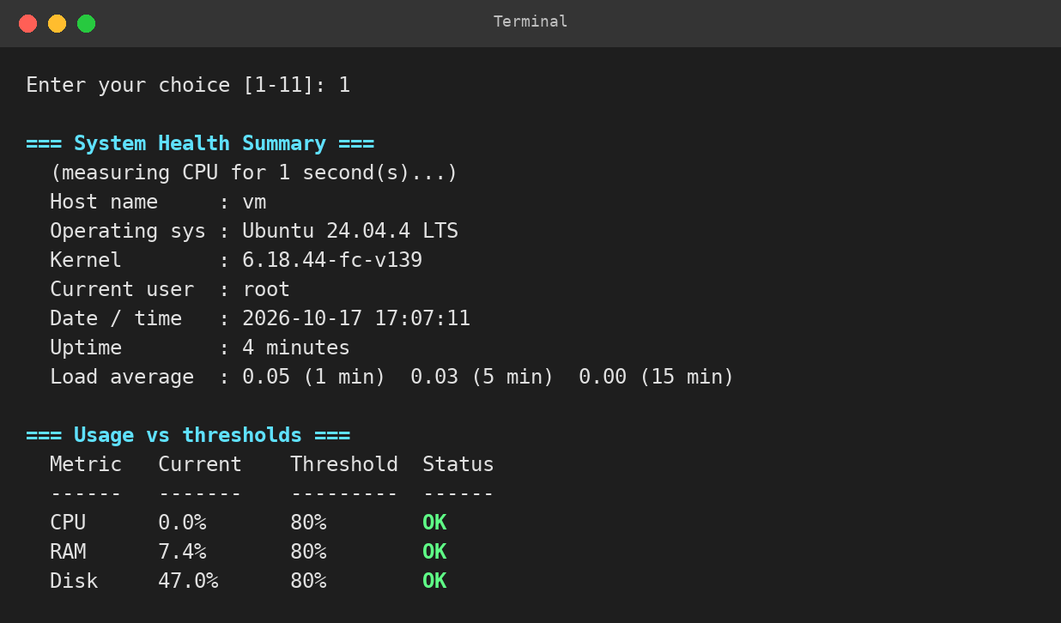
Figure 4.1: System health summary (menu option 1) showing CPU, RAM, Disk alerts
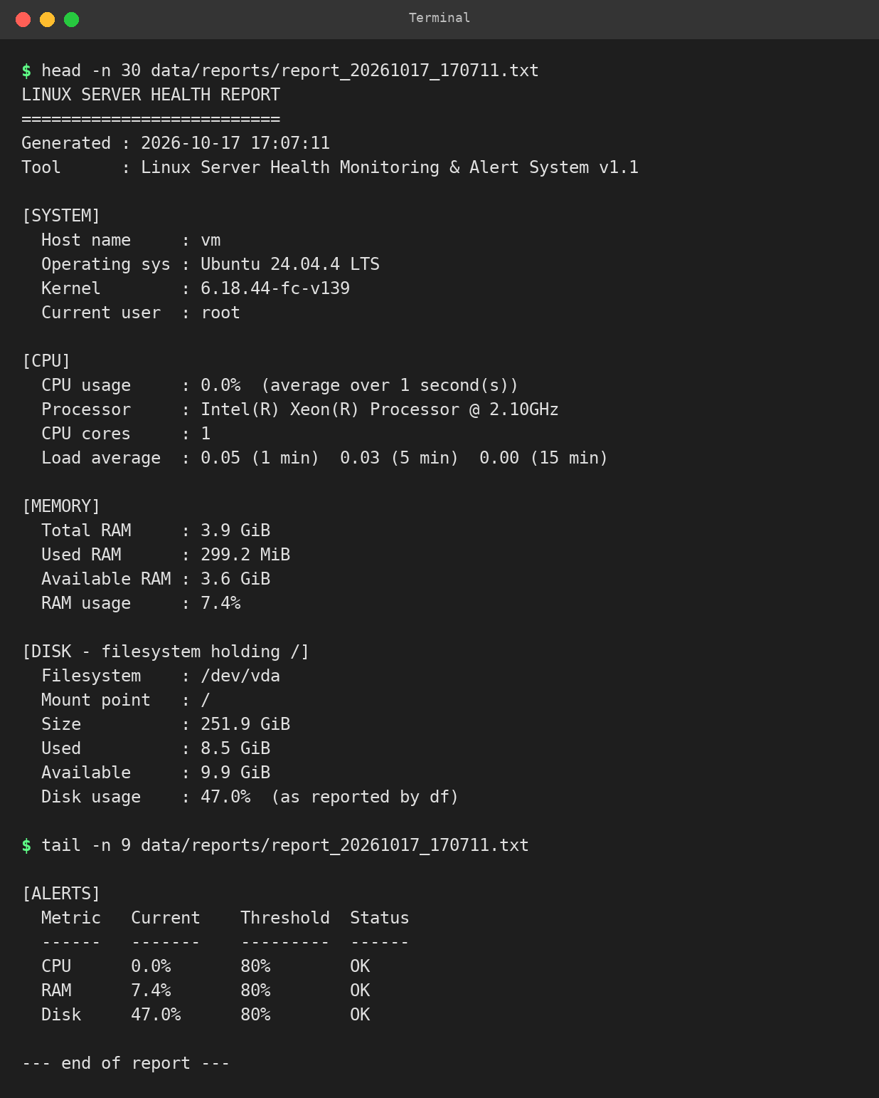
Figure 4.2: Generated report file contents

4.1.2 Web Dashboard Results
The Flask web dashboard was started with python3 web/app.py and opened in a browser at http://localhost:5000. The /api/metrics endpoint returned a well-formed JSON object containing all monitored values. The browser dashboard rendered all sections correctly and updated every 3 seconds without requiring a page reload. The page was also opened in a headless Chromium browser for several refresh cycles and no JavaScript errors were reported. The other tabs were used from the browser: new thresholds were saved to data/config.conf and applied to the alerts immediately, two reports were generated and listed with Download buttons, an invalid service name was rejected, the log showed each action, and the Processes tab ranked a deliberately CPU-heavy test process first. Figures 4.3 to 4.8 show these tabs.
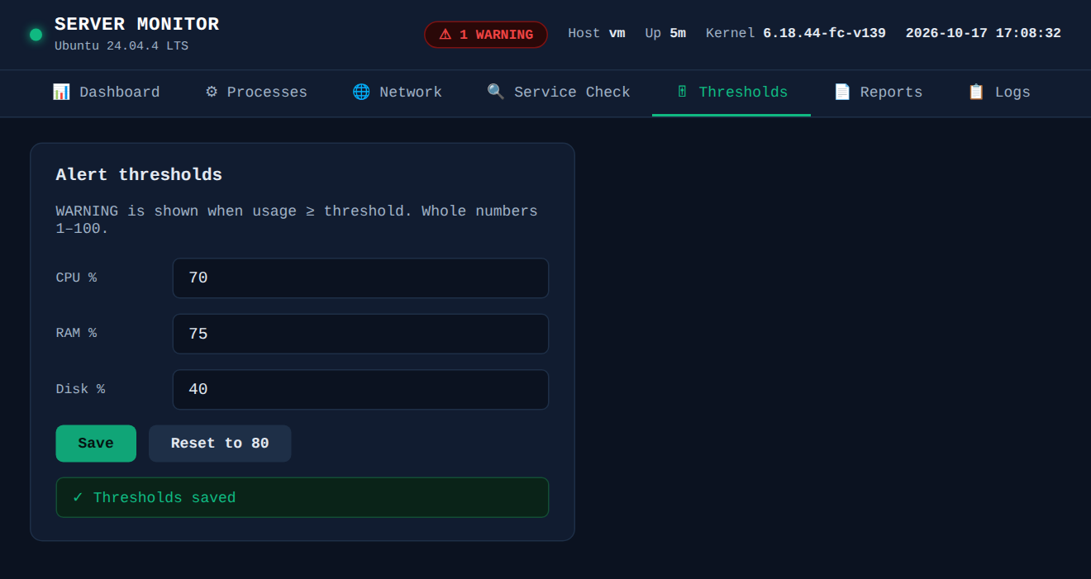
Figure 4.3: Web dashboard – Thresholds tab after saving new values (CPU 70, RAM 75, Disk 40)
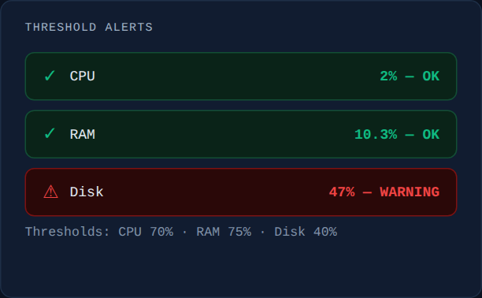
Figure 4.4: Alert card showing WARNING for Disk (47% against a 40% threshold)
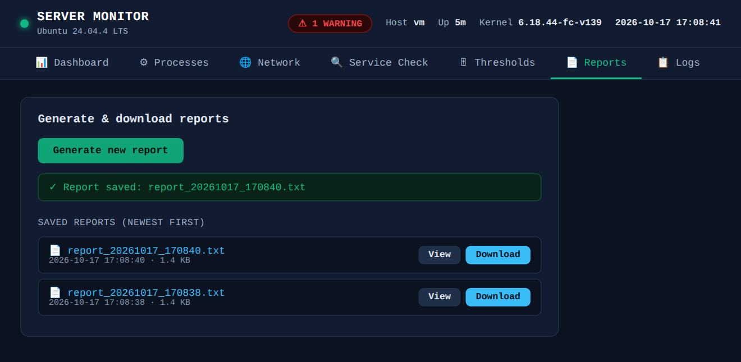
Figure 4.5: Web dashboard – Reports tab with generated reports and Download buttons
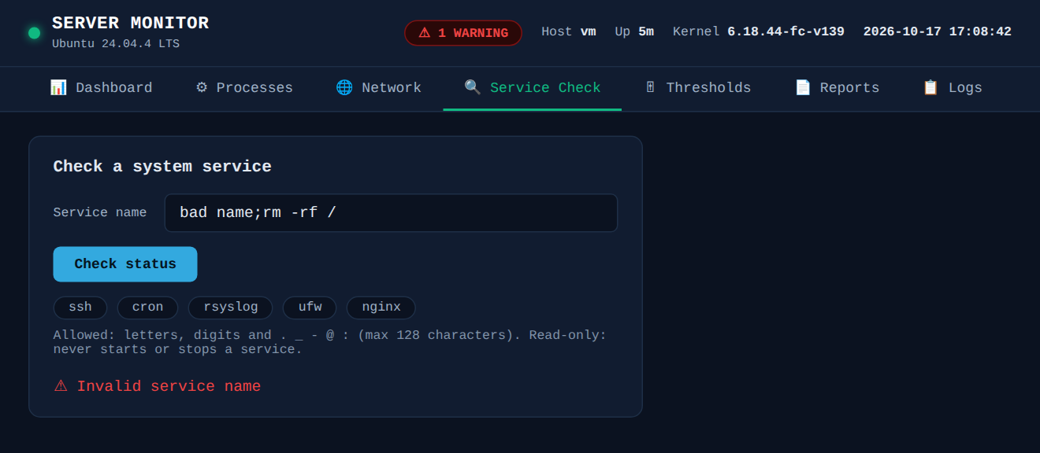
Figure 4.6: Web dashboard – Service Check tab rejecting an invalid service name
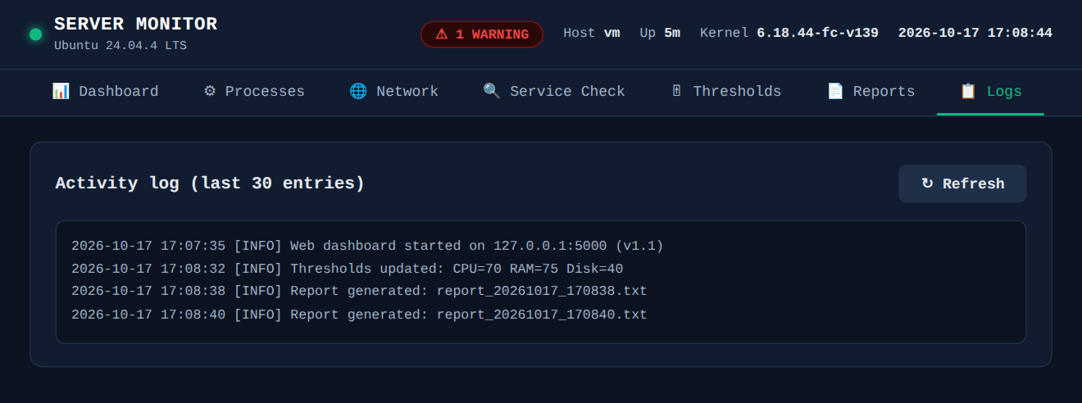
Figure 4.7: Web dashboard – Logs tab showing the activity log
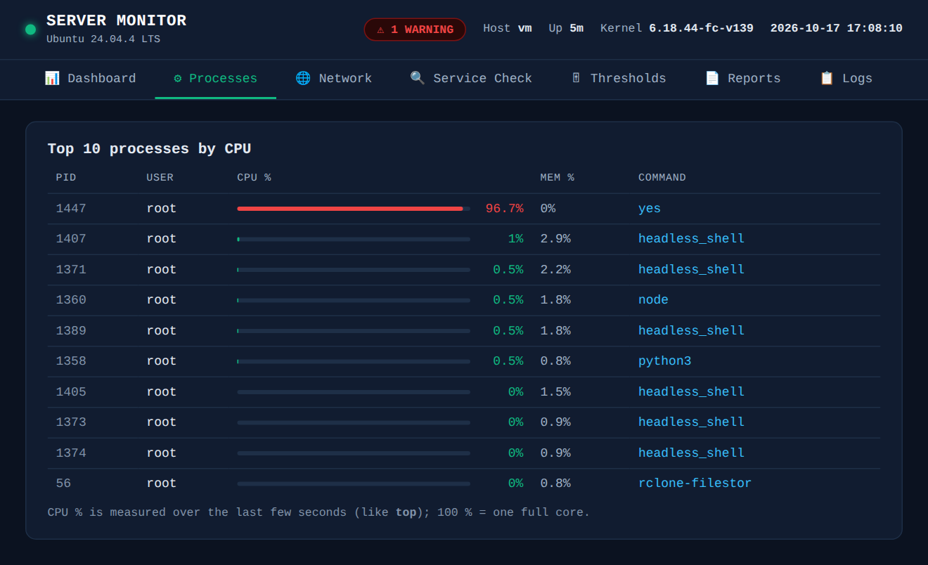
Figure 4.8: Web dashboard – Processes tab ranking a CPU-heavy test process (yes) first

4.2 Testing and Validation
Testing was performed to verify the main functions of the Linux Server Health Monitoring and Alert System. The test cases cover input validation, metric accuracy, threshold alert logic, report generation, log output, failure handling, and the web dashboard API.
Test Case | Expected Result | Actual Result | Status
bash -n syntax check | No output, exit code 0 | No errors reported | Pass
Valid menu choice (e.g. 2) | CPU details shown, return to menu | CPU details displayed | Pass
Invalid menu input (abc, 0, 12) | Error message, menu redisplayed | Error shown, no crash | Pass
Threshold set to 1 → menu 8 | All three metrics show WARNING | WARNING shown for all | Pass
Threshold set to 100 → menu 8 | All three metrics show OK | OK shown for all | Pass
Invalid threshold (0, 101, abc) | Rejected, old value kept | All rejected correctly | Pass
Menu 9 (generate report) | File created in data/reports/ | Report file created | Pass
Same-second report generation ×3 | Files named _1, _2, no overwrite | Unique names generated | Pass
Menu 6: valid service name | Status shown (active/inactive) | Status displayed (VM required) | VM test
Menu 6: name with semicolon | Rejected with error | Rejected, nothing executed | Pass
Config file with $(touch /tmp/x) | Line ignored, file repaired | /tmp/x not created | Pass
Flask /api/metrics endpoint | HTTP 200 with JSON body | 200 OK, JSON returned | Pass
Dashboard auto-refresh | Values update every 3 seconds | Updates confirmed | Pass
Ctrl+C at menu | Clean exit, log entry written | Clean exit observed | Pass
RAM vs free -m | Values match within ±5 MB | Match confirmed | Pass
Disk vs df -h / | Use% identical | Identical | Pass
Cron modes: --check and --report | Alert table printed; report saved; exit status 0 (all OK) or 1 (WARNING) | Exit 0 with defaults, exit 1 with thresholds at 1; report file created | Pass
Web thresholds form: 0, 101, 5.5, abc | HTTP 400 and old values kept (all-or-nothing) | 400 returned for every bad value; config.conf unchanged | Pass
Web thresholds saved, then terminal --check | Terminal tool uses the same thresholds | Terminal showed the thresholds saved by the web page | Pass
Web service check: space, semicolon, 129 characters | Name rejected, nothing executed | “Invalid service name” shown for each name | Pass
Web service check of a stopped service (simulated systemctl output) | State shown as inactive / disabled, not unknown | Correct states displayed (regression test) | Pass
Web report: generate, list, view, download | Report file created, listed, previewed and downloadable | All four actions worked in the browser | Pass
Web report download with bad file name | Request rejected, no other file served | 400 for evil.txt and 404 for ../ paths | Pass
POST request without the X-Requested-With header | HTTP 403 and nothing changed | 403 returned; thresholds and reports untouched | Pass
Automated tests (web/test_app.py) | All unit tests pass | 28 tests passed | Pass
Dashboard in Chromium: all tabs, validation, offline banner, 375 px width | No failed checks and no unexpected JavaScript errors | 36 of 36 checks passed | Pass
Web API response time | Live data returned without waiting for a measurement | About 4 ms per /api/metrics request (earlier version: 513 ms) | Pass

5. Conclusion and Future Scope

5.1 Conclusion
The Linux Server Health Monitoring and Alert System provided comprehensive practical experience in Linux system administration by implementing CPU monitoring, RAM monitoring, disk space monitoring, uptime and load tracking, user session monitoring, process inspection, system service status checking, configurable threshold alerts, timestamped report generation, and activity logging — all within a single cohesive project.
The project was delivered in two complementary forms: an interactive Bash terminal menu (server_monitor.sh) and a live Flask web dashboard (app.py). Both tools read real data from the Linux kernel (/proc filesystem and standard utilities), and both agree on the measured values. The alert engine compares readings with user-configurable thresholds and clearly distinguishes OK and WARNING states.
The project achieved all stated objectives: a guided interface for both terminal and browser users, accurate real-time metrics, configurable thresholds, clear visual alerts, automated report generation, a structured activity log, and graceful error handling when utilities or systemd are unavailable. It also demonstrated core Linux administration concepts: process management, filesystem inspection, user activity monitoring, permission handling, service status checking, and cron automation.

5.2 Future Scope
The project can be enhanced in the following ways:
- Continuous monitoring mode: A cron-driven loop or a background daemon that monitors thresholds at fixed intervals, writes to a history CSV, and triggers email or SMS notifications when WARNING conditions persist.
- SSH remote monitoring: Allow the Bash script to connect to remote hosts via SSH and collect metrics from multiple machines in a single session, or aggregate data in the Flask dashboard.
- Authentication for the web dashboard: Add a simple login page to the Flask application so that the dashboard is not accessible without a password when deployed on a shared network.

References
1. Ubuntu Documentation – Ubuntu Server Documentation. Available at: https://ubuntu.com/server/docs/
2. GNU Project – GNU Bash Reference Manual. Available at: https://www.gnu.org/software/bash/manual/bash.html
3. GNU Project – GNU Coreutils Manual (df, free, ps, who, uptime). Available at: https://www.gnu.org/software/coreutils/manual/coreutils.html
4. The Linux Kernel Organisation – /proc filesystem documentation. Available at: https://www.kernel.org/doc/html/latest/filesystems/proc.html
5. Ubuntu Manpages – crontab(1), systemctl(1). Available at: https://manpages.ubuntu.com/
6. Flask Documentation – Flask Web Framework. Available at: https://flask.palletsprojects.com/
7. GNU Project – GNU Tar Manual. Available at: https://www.gnu.org/software/tar/manual/tar.html
8. Python Software Foundation – Python 3 Documentation. Available at: https://docs.python.org/3/
9. Alliance University – Course E1ITA307: Linux System Administration. Project guidelines and evaluation rubric.

Appendix A – System Components Summary
Component | Description
server_monitor.sh | Bash menu tool. 11 options, plus --check and --report modes for cron. Reads /proc/stat, /proc/meminfo, df, ps, who, systemctl.
app.py (Flask) | Python web server. /api/metrics plus service, threshold, report and log endpoints. Embedded HTML/JS dashboard with seven tabs.
data/config.conf | Plain-text thresholds: CPU_THRESHOLD, RAM_THRESHOLD, DISK_THRESHOLD. Shared by both tools.
logs/app.log | Timestamped [INFO]/[WARN]/[ERROR] log. Never sourced; append-only.
Cron | Runs server_monitor.sh --check every 5 min and --report every 15 min.
backup/project_backup.tar.gz | Compressed backup of scripts and config; recovery tested with tar -xzf.

Appendix B – Shell Script Source Code
The following excerpts show the key measurement, validation and configuration functions from server_monitor.sh. The full script is supplied as a separate file (server_monitor.sh).

B.1 CPU Measurement Function
collect_cpu() {
CPU_X10=""; CPU_ERROR=""
local t1 i1 t2 i2 dt di busy
if ! have_cmd sleep; then
CPU_ERROR="the 'sleep' command is missing"; return 1; fi
if ! read_cpu_counters; then
CPU_ERROR="cannot read /proc/stat"; return 1; fi
t1=$CPU_TOTAL; i1=$CPU_IDLE
sleep "$CPU_SAMPLE_SECONDS"
if ! read_cpu_counters; then
CPU_ERROR="cannot read /proc/stat"; return 1; fi
t2=$CPU_TOTAL; i2=$CPU_IDLE
dt=$(( t2 - t1 )); di=$(( i2 - i1 ))
if [ "$dt" -le 0 ]; then
CPU_ERROR="no CPU time elapsed"; return 1; fi
busy=$(( dt - di ))
[ "$busy" -lt 0 ] && busy=0
CPU_X10=$(( busy * 1000 / dt ))
[ "$CPU_X10" -gt 1000 ] && CPU_X10=1000
return 0
}

B.2 Memory Measurement Function
collect_memory() {
MEM_X10=""; MEM_ERROR=""
local key val total="" avail="" free="" buffers="" cached=""
if [ ! -r /proc/meminfo ]; then
MEM_ERROR="cannot read /proc/meminfo"; return 1; fi
while IFS=': ' read -r key val _; do
case "$key" in
MemTotal) total=$val ;;
MemAvailable) avail=$val ;;
MemFree) free=$val ;;
Buffers) buffers=$val ;;
Cached) cached=$val ;;
esac
done </proc/meminfo
[ -z "$avail" ] && avail=$(( free + buffers + cached ))
MEM_TOTAL_KB=$total; MEM_AVAIL_KB=$avail
MEM_USED_KB=$(( total - avail ))
MEM_X10=$(( MEM_USED_KB * 1000 / total ))
return 0
}

B.3 Alert Engine
valid_threshold() {
local v=$1
[[ $v =~ ^[1-9][0-9]{0,2}$ ]] || return 1
(( 10#$v >= 1 && 10#$v <= 100 )) || return 1
return 0
}

valid_service_name() {
local re='^[A-Za-z0-9][A-Za-z0-9@._:-]{0,127}$'
[[ $1 =~ $re ]]
}

B.4 Config File Parser (safe – no source)
load_config() {
CPU_THRESHOLD=$DEFAULT_CPU_THRESHOLD
RAM_THRESHOLD=$DEFAULT_RAM_THRESHOLD
DISK_THRESHOLD=$DEFAULT_DISK_THRESHOLD
[ -f "$CONFIG_FILE" ] || { save_config; return 0; }
local line key val got_cpu=0 got_ram=0 got_disk=0
while IFS= read -r line || [ -n "$line" ]; do
line=${line%$'\r'}
[[ -z $line || $line == \#* ]] && continue
if [[ $line =~ ^(CPU|RAM|DISK)_THRESHOLD=([0-9]{1,3})$ ]]; then
key=${BASH_REMATCH[1]}; val=${BASH_REMATCH[2]}
if valid_threshold "$val"; then
case "$key" in
CPU) CPU_THRESHOLD=$val; got_cpu=1 ;;
RAM) RAM_THRESHOLD=$val; got_ram=1 ;;
DISK) DISK_THRESHOLD=$val; got_disk=1 ;;
esac
fi
fi
done <"$CONFIG_FILE"
}

B.5 Non-interactive Modes for Cron
run_check() {
collect_cpu; collect_memory; collect_disk
header "Threshold Check ($(now))"
print_alerts
log_msg INFO "Non-interactive check (--check)"
local c m d r
c=$(metric_status "$CPU_X10" "$CPU_THRESHOLD")
m=$(metric_status "$MEM_X10" "$RAM_THRESHOLD")
d=$(metric_status "$DISK_X10" "$DISK_THRESHOLD")
for r in "$c" "$m" "$d"; do
[ "$r" = "WARNING" ] && return 1
done
return 0
}

# in main():
--check) mode="check" ;;
--report) mode="report" ;;
...
if [ "$mode" = "check" ]; then
log_msg INFO "Started in --check mode (user ${USER:-$(id -un 2>/dev/null)})"
run_check
exit $?
fi

Appendix C – Flask Dashboard Source Code

C.1 Metrics Collector Functions (app.py – excerpt)
def _cpu_counters():
parts = _read("/proc/stat").split("\n", 1)[0].split()
if not parts or parts[0] != "cpu":
return None
v = [int(x) for x in parts[1:9] if x.isdigit()]
v += [0] * (8 - len(v))
return sum(v), v[3] + v[4] # total, idle(+iowait)

class Sampler(threading.Thread): # background thread, 1 sample/second
def sample(self):
now = time.monotonic()
cpu = _cpu_counters()
if cpu and self._cpu:
dt = cpu[0] - self._cpu[0]
di = cpu[1] - self._cpu[1]
if dt > 0:
busy = (dt - di) * 100.0 / dt
with self.lock:
self.cpu = round(max(0.0, min(100.0, busy)), 1)
self.ready.set()
self._cpu = cpu
...

def mem_info():
kv = _meminfo()
total = kv.get("MemTotal", 0)
avail = kv.get("MemAvailable", kv.get("MemFree", 0)
+ kv.get("Buffers", 0) + kv.get("Cached", 0))
avail = min(avail, total)
used = total - avail
return {"total_mb": round(total / 1024, 1),
"used_mb": round(used / 1024, 1),
"free_mb": round(avail / 1024, 1),
"percent": round(used * 100 / total, 1) if total else None}

C.2 Flask API Route
def snapshot():
sampler.ready.wait(3)
cpu, net, procs = sampler.read()
t, mem = load_thresholds(), mem_info()
dk, info = disk_info(), static_info()
alerts = {"cpu": status(cpu, t["cpu"]),
"ram": status(mem["percent"], t["ram"]),
"disk": status(dk["percent"], t["disk"])}
return {"version": VERSION,
"cpu": {"percent": cpu, **info["cpu"]},
"mem": mem, "disk": dk, "load": load_avg(),
"uptime": uptime_str(), "os": info["os"],
"procs": procs, "net": net,
"users": cached("users", 5, logged_users),
"disks": cached("disks", 10, all_disks),
"thresholds": t, "alerts": alerts,
"warnings": sum(v == "WARNING" for v in alerts.values()),
"ts": time.strftime("%Y-%m-%d %H:%M:%S")}

@app.route("/api/metrics")
def api_metrics():
return jsonify(snapshot())

C.3 Service and Threshold Routes
@app.route("/api/service", methods=["POST"])
def api_service():
body = request.get_json(silent=True) or {}
# never truncated: a 129-character name is simply invalid
name = str(body.get("name", "")).strip()
if not name:
return jsonify({"error": "Service name required"}), 400
return jsonify(check_service(name))

def check_service(name):
"""Read-only service status through one `systemctl show` call."""
if not _SERVICE_RE.fullmatch(name):
return {"error": "Invalid service name"}
if not shutil.which("systemctl") or not SYSTEMD_DIR.exists():
return {"error": "systemd is not running on this machine"}
rc, out = _run(["systemctl", "show", "--property=" + SERVICE_PROPS,
"--", name]) # read-only: show, never start/stop
...

@app.before_request
def _csrf_guard():
# A cross-site page cannot send this header (this app allows no CORS).
ok = request.headers.get("X-Requested-With") == "monitor-ui"
if request.method == "POST" and not ok:
abort(403)

